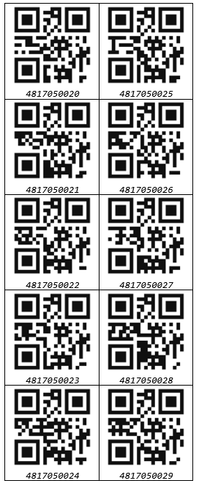 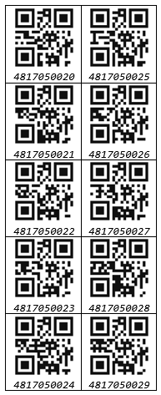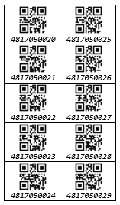

|  |  |
| --- | --- |
| *4817050020* | *4817050025* |
| *4817050021* | *4817050026* |
| *4817050022* | *4817050027* |
| *4817050023* | *4817050028* |
| *4817050024* | *4817050029* |

|  |  |
| --- | --- |
| *4817050020* | *4817050025* |
| *4817050021* | *4817050026* |
| *4817050022* | *4817050027* |
| *4817050023* | *4817050028* |
| *4817050024* | *4817050029* |

|  |  |
| --- | --- |
| *4817050020* | *4817050025* |
| *4817050021* | *4817050026* |
| *4817050022* | *4817050027* |
| *4817050023* | *4817050028* |
| *4817050024* | *4817050029* |